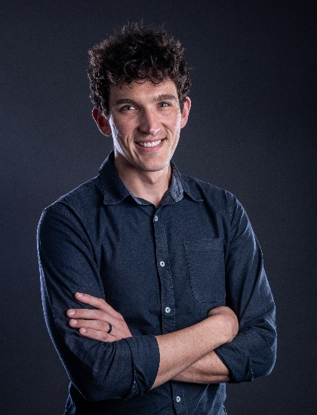

Presenter - JanLouis du Toit, Principal Consultant - Business Transformation, AMC Consultants.

Bio:
JanLouis integrates a background in engineering management and business transformation with technical mining expertise to help global mining organizations navigate the evolving challenges of the resources sector. He specializes in bridging the gap between complex engineering studies and strategic operational improvements, working with multidisciplinary teams to deliver practical, value-driven solutions. His experience encompasses the full project lifecycle, from managing technical feasibility studies to overseeing major capital project execution. JanLouis is driven by a passion for modernizing the industry through implementing innovative solutions, seeking to transform traditional operations into future-ready, high-performing assets.

Presentation title:
Managing Innovation Projects to Improve Underground Mining Operations – Insights from the Field

Abstract:
As global demand for minerals rises alongside the transition to a lower-carbon economy, underground mining is facing increasing cost, complexity, and operational challenges due to tougher-to-exploit orebodies and higher ESG standards. Innovation is essential to maintain competitiveness and many mining organizations struggle to successfully implement innovation projects to improve underground operations. The findings of this study address that gap by developing a practical project management framework tailored to underground mining innovation, informed by a literature review and interviews with experienced mining practitioners worldwide. The presentation shares real-world insights, critical success factors, and practical tools to help technical professionals execute innovation projects to improve safety, efficiency, and operational performance, translating structured innovation efforts into measurable, on-site results.

