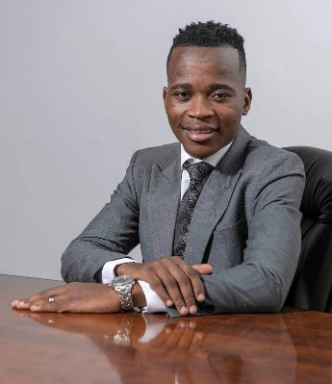
Presenter: Phuthego Moganedi, Group Head: Business Improvement, Fraser Alexander
BIO:
Phuthego Moganedi is a metallurgical engineer and business improvement leader with extensive experience applying data, analytics, and digital tools to strengthen decision-making across mining operations.

He currently serves as the Group Head: Business Improvement at Fraser Alexander, where he leads group-wide initiatives spanning integrated planning, performance management, operational excellence, and digital enablement across South Africa, the rest of Africa, and international operations. His work focuses on embedding data into operational and management processes - ensuring insights translate into measurable improvements in productivity, cost control, and profitability rather than remaining at a reporting level.

Phuthego holds a Metallurgical Engineering degree (Wits) and is currently completing a Master of Management in Finance & Investments (MMFI) at Wits Business School, strengthening his ability to connect data analytics, operational performance, financial outcomes, and strategic decision-making. His career includes senior roles at Anglo American, including serving as Chief of Staff at Africa’s largest open-pit mine, where he supported execution of complex operational strategies and performance improvement programmes.

He brings a practical, systems-oriented perspective on how data, analytics, and emerging technologies can be integrated into planning, control, and execution to support safer, more efficient, and more sustainable mining operations. In 2026, he was recognised as a Future Leader in the Mining Elites in Africa Yearbook for his contribution to innovation and operational excellence in the African mining sector.
MISSING: Presentation title & abstract

