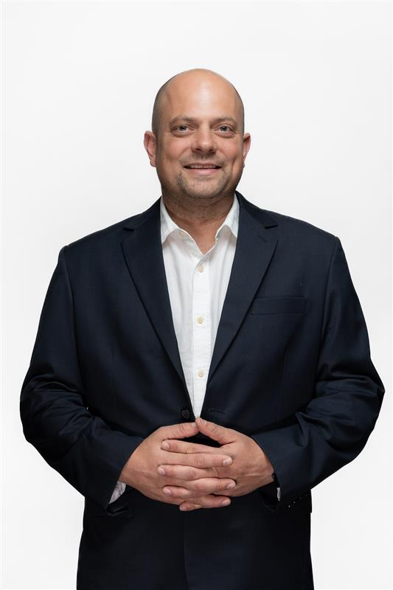
Panelist - Shaun Vorster, Head of Digital Transformation & Partner, Forvis Mazars
Bio:
Chief Digital Transformation Officer, Overseeing the Digital Transformation Office, Shaun leads multiple sector-specific strategies and initiatives to drive regional growth and enhance economic development. With a focus on innovation and digital excellence, he is committed to equipping the organization with the tools and mindset needed to succeed in a fast-changing world.

