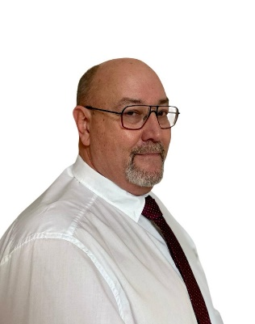

Presenter & panelist: Vaughan Chamberlain, CEO and MD, Amira Global
Bio:
Experienced Senior executive with a demonstrated history of working in the mining & metals industry. Skilled in Mineral Exploration, Geology, Sampling, Geostatistics, Mining, Geometallurgy and Metallurgy. Strong professional with an Honours in Geology (BSc Hons) from the University of Kwa Zulu Natal and a Master of Engineering (MEng) focused on Mining from University of the Witwatersrand.
Currently leading Amira Global, is the leading research collaboration platform for collaborative research for the global Mineral Resource industry. Amira Global is a not-for-profit company headquartered in Perth, Australia – with offices in Johannesburg, Accra and Santiago. Its members include most of the world’s largest mining companies
Presentation title:
Carbon Sequestration in Africa

Abstract:
Carbon sequestration efforts in Africa are emerging but face unique challenges and opportunities. The continent's industrial base is growing, with cement, power, and natural gas sectors as primary candidates for geological CCS deployment. Biomass resources offer potential for BECCS, particularly in regions with sustainable agricultural residues.
However, infrastructure for CO₂ transport and storage is limited, and policy frameworks are still developing. Social acceptance and financing remain critical barriers, but international partnerships and climate finance mechanisms are increasingly supporting pilot projects and feasibility studies.

